Name: _______________________________________________
Foundation Unit 17 topic test
Date:
Time: 40 minutes
Total marks available: 36
Total marks achieved: ______

Questions
Q1.
(a) In the space below, draw a sketch of a rectangle.
(1)
(b)
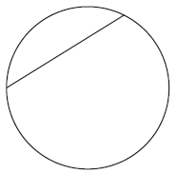
Write down the mathematical name for the straight line inside this circle.
...........................................................
(1)
(c) Here is a solid shape.
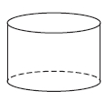
Write down the mathematical name for this solid shape.
...........................................................
(1)
(Total for question = 3 marks)
Q2.
A circle has a diameter of 140 cm.
Work out the circumference of the circle.
Give your answer correct to 3 significant figures.
........................................................... cm
(Total for Question is 2 marks)

Q3.
Susan has a round cake.
The cake has a diameter of 20 cm.
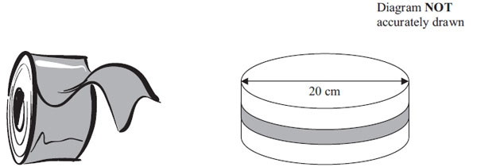
Susan wants to put a ribbon round the cake.
What is the least length of ribbon she can use?

..............................................................................................................................................
(Total for Question is 3 marks)

Q4.
* Saphia is organising a conference.
People at the conference will sit at circular tables.
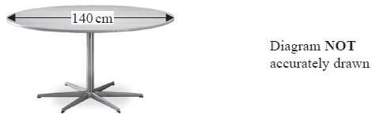
Each table has a diameter of 140 cm.
Each person needs 60 cm around the circumference of the table.
There are 12 of these tables in the conference room.
A total of 90 people will be at the conference.
Are there enough tables in the conference room?
(Total for Question is 4 marks)

Q5.
The diagram shows a semicircle drawn inside a rectangle.
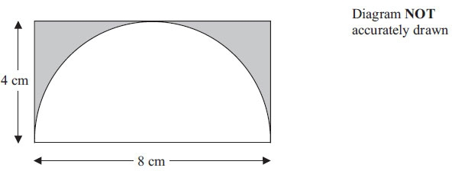
The semicircle has a diameter of 8 cm.
The rectangle is 8 cm by 4 cm.
Work out the area of the shaded region.
Give your answer correct to 3 significant figures.

. . . . . . . . . . . . . . . . . . . . . . . . cm²
(Total for Question is 4 marks)
Q6.

The arc ABC is a quarter of a circle with centre O and radius 4.8 cm.
AC is a chord of the circle.
Work out the area of the shaded segment.
Give your answer correct to 3 significant figures.
........................................................... cm²
(Total for question = 3 marks)

Q7.
The diagram shows a trapezium ABCD and two identical semicircles.
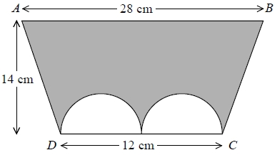
The centre of each semicircle is on DC.
Work out the area of the shaded region.
Give your answer correct to 3 significant figures.
........................................................... cm²
(Total for question = 4 marks)

Q8.
The diagram shows a container used to store oil.
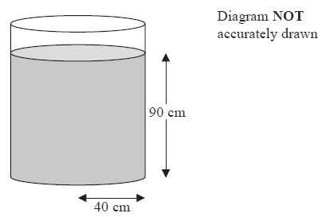
The container is in the shape of a cylinder of radius 40 cm.
The height of the oil in the container is 90 cm.
65 litres of oil are taken from the container.
1 litre = 1000 cm³.
Work out the new height of the oil in the container.
Give your answer correct to one decimal place.
.........................cm
(Total for Question is 4 marks)

Q9.
Here is a diagram showing a rectangle, ABCD, and a circle.
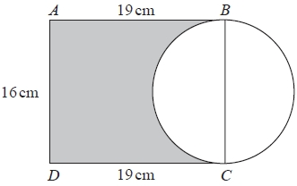
BC is a diameter of the circle.
Calculate the percentage of the area of the rectangle that is shaded.
Give your answer correct to 1 decimal place.
...........................................................%
(Total for question is 4 marks)

Q10.
* Mr Weaver's garden is in the shape of a rectangle.
In the garden
there is a patio in the shape of a rectangle
and two ponds in the shape of circles with diameter 3.8 m.
The rest of the garden is grass.
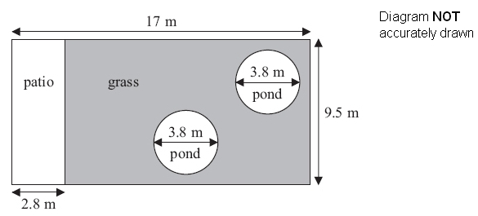
Mr Weaver is going to spread fertiliser over all the grass.
One box of fertiliser will cover 25 m² of grass.
How many boxes of fertiliser does Mr Weaver need?
You must show your working.

(Total for Question is 5 marks)
Examiner's Report
Q1.
Almost all students drew a sketch of a rectangle in part (a), with most using a ruler. In part (b), many students knew that the straight line was a chord. A variety of incorrect answers were seen, the most common of which were sector and diameter. Students were more successful in part (c) with the majority able to identify the shape as a cylinder.

Q2.
About a half of the candidates used the wrong formula for the circumference of the circle with the area formula often being used. Full marks were awarded for those candidates that gave an answer in the range 439.6 to 440 but only one mark if they rounded to down to 439 on the answer line unless the correct answer was seen in the working space whereupon they could score both marks.

Q3.
Surprisingly few candidates reached the correct final answer with units on a relatively straightforward circumference question, albeit in the context of ribbon round a cake. Several candidates used the area formula or missed the required units. The mark for giving centimetres associated with a final answer was gained by others who had made no progress with circumference.

Q4.
Fully correct solutions to this problem were rarely seen but those students who appreciated the need to calculate the circumference and remembered the appropriate formula often went on to gain all the marks. The most common correct route was a calculation showing that the tables would only seat 84. Area or π × radius for circumference were sometimes seen. Many weaker students simply took 140 cm as the circumference for each table and often divided by 60 to conclude that each table would only take 2(.5) people; or they multiplied 140 by 12 and divided by 60.

Q5.
A fairly small number of candidates achieved full marks on this question. Candidates often arrived at a correct final answer between 6.86 and 6.88 from an incorrect method. The majority of candidates who arrived at the final answer gave it to three decimal places as opposed to three significant figures, but were not penalised for this.
It was disappointing to note that a number of candidates failed to score. Candidates commonly used the wrong formula for calculating the area of a circle, finding the circumference instead. A small number of candidates were able to find the area of the circle correctly but then failed to halve this, scoring no further marks. This question highlighted many candidates' poor knowledge of formulae associated with circles.

Q6.
No Examiner's Report available for this question

Q7.
No Examiner's Report available for this question

Q8.
Very few students gained marks on this question with less than 5− gaining full marks. A few showed beginning steps to find the cross-section area or cylinder volume but the relatively large numbers involved and conversion aspect presented too much of a challenge for most. The most successful students did set out their working well and often gave a descriptive commentary which may well have helped them to structure their solution.

Q9.
No Examiner's Report available for this question

Q10.
This was a QWC question. As such, candidates were expected to show clear working and to reach and state a conclusion based on their calculations. The conclusion had to be the correct number of boxes for the area of grass they had calculated and to earn the mark the candidate had to display enough working to allow at least 1 method mark to be obtained. The most successful candidates were those that had a clear idea of what to do and set out there working in a systematic manner.
There were many pleasing attempts at the question although few achieved all five marks, mainly because they could not work out the area of the pond. In fact, many candidates thought that the area of the pond was 3.8, not realising that the 3.8m above the double arrowed line was the diameter. In addition many worked out π ×3.8 for the area. A common error, when faced with an answer of, for example, 5.3 to their calculations, was to round down to 5.

Mark Scheme
Q1.
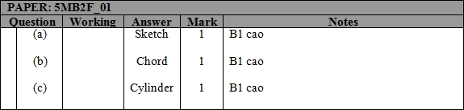

Q2.
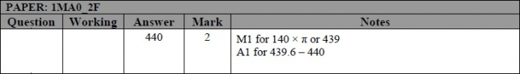

Q3.
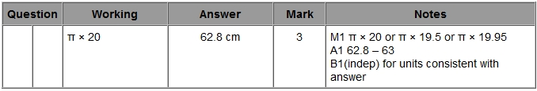

Q4.
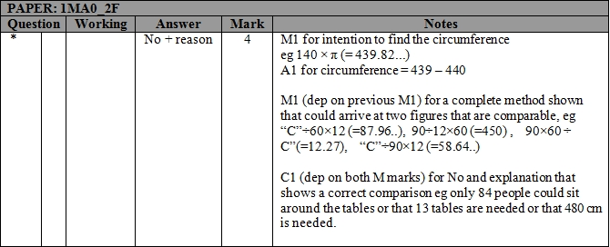

Q5.
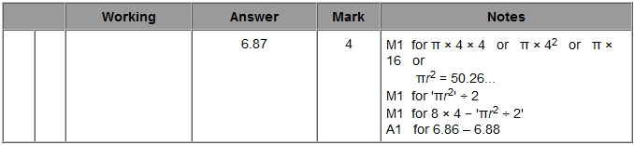

Q6.
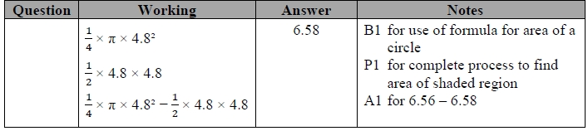

Q7.
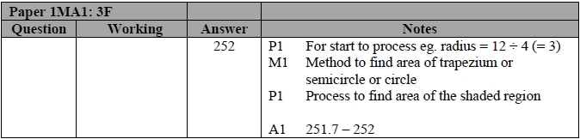

Q8.
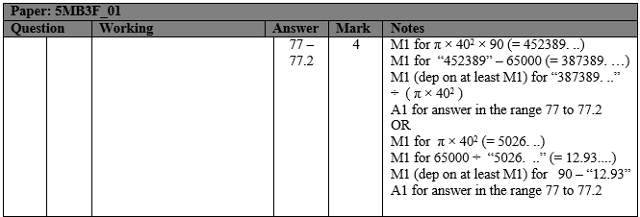

Q9.
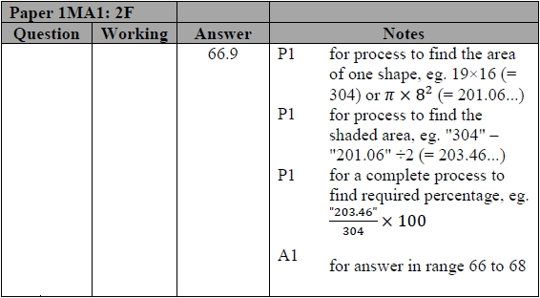

Q10.
